Create Cognitive AI Service on Azure and Ai for text

Overview: The purpose of this AI development toolkit is to measure the sentiment of a given text and identify the emotional tone expressed in it. We have chosen the Microsoft Client API toolkit because it offers a comprehensive set of features for sentiment analysis, including support for multiple languages, customization options, and integration with other Microsoft services. Measuring sentiment is an important task in many applications, such as customer service, market research, and social media analysis. By using this toolkit, our application can accurately identify the emotional tone of a given text and provide valuable insights to our users.

- Prerequisite
- Create Azure subscription if we have not gotten one. https://azure.microsoft.com/free/cognitive-services
(See devop section on how to create free account or pay as you go)
- Create a Text Analytics resource
https://ms.portal.azure.com/#create/Microsoft.CognitiveServicesServicesTextAnalytics
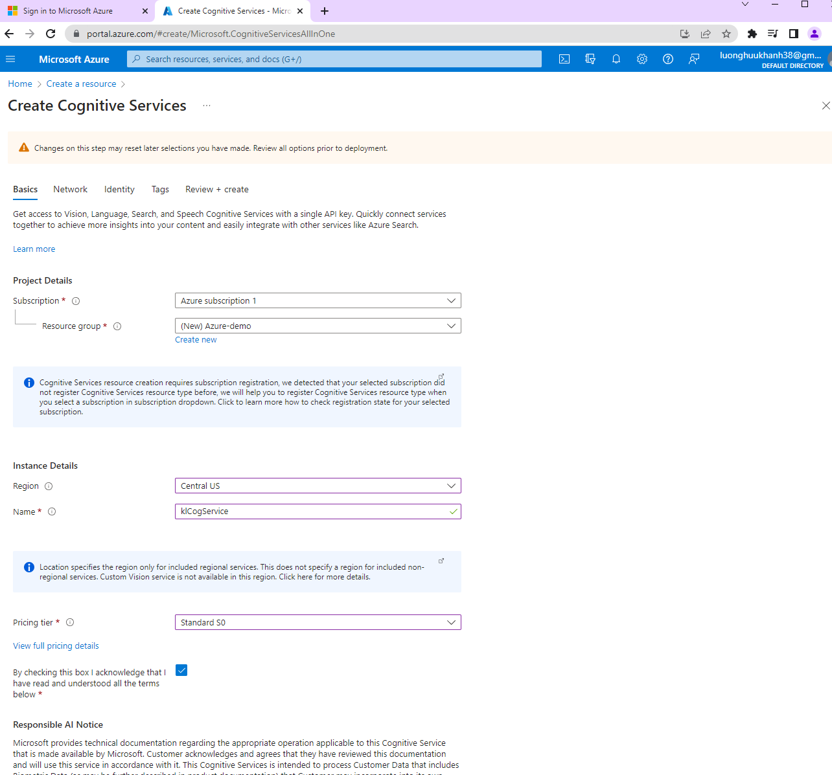
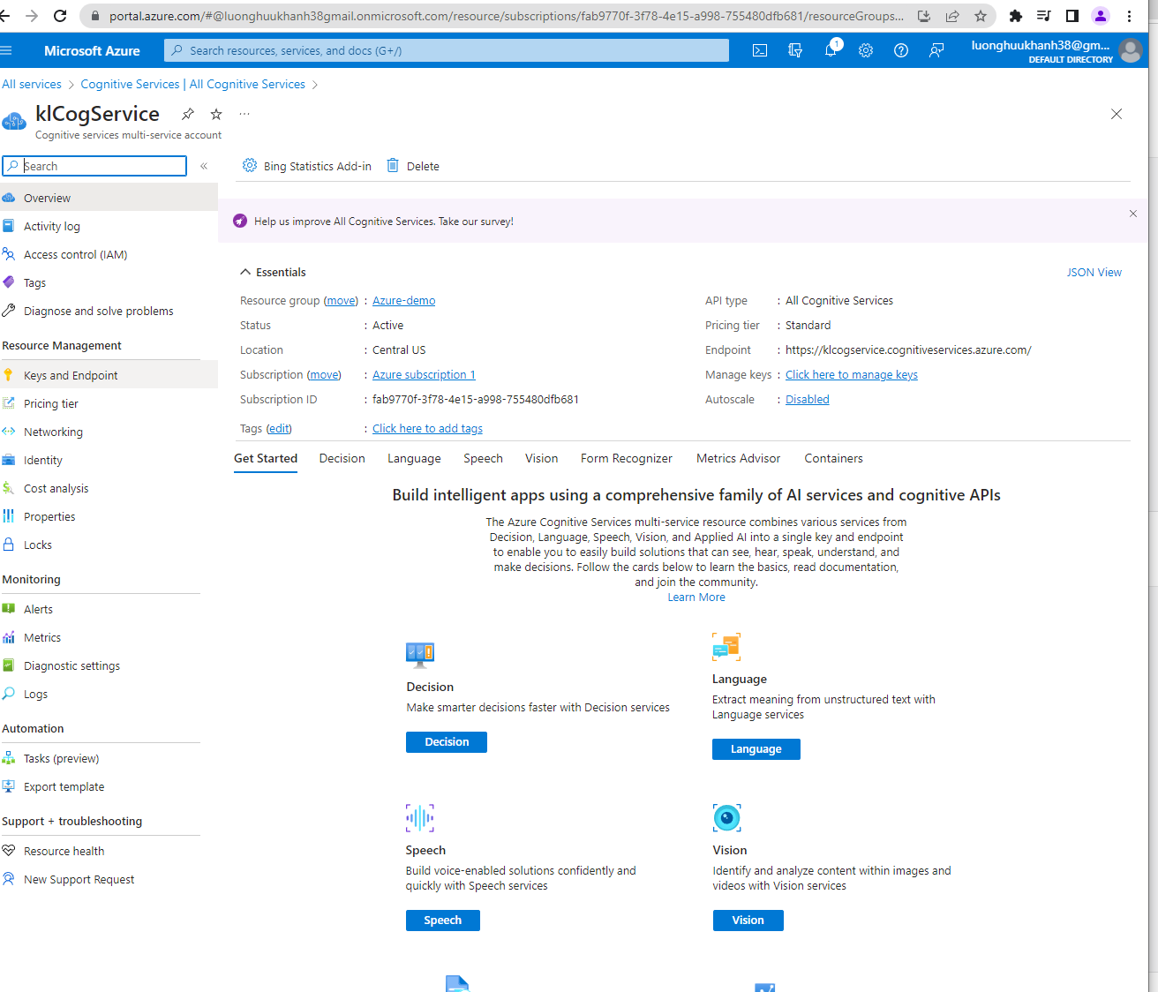

- Write a program (please see the py program zip file)
- Install library
In order to import azure.core, azure.ai to work, we need to install the azure.core package as the following
Click on File->Setting->Python Interpreter->search for azure-core->install
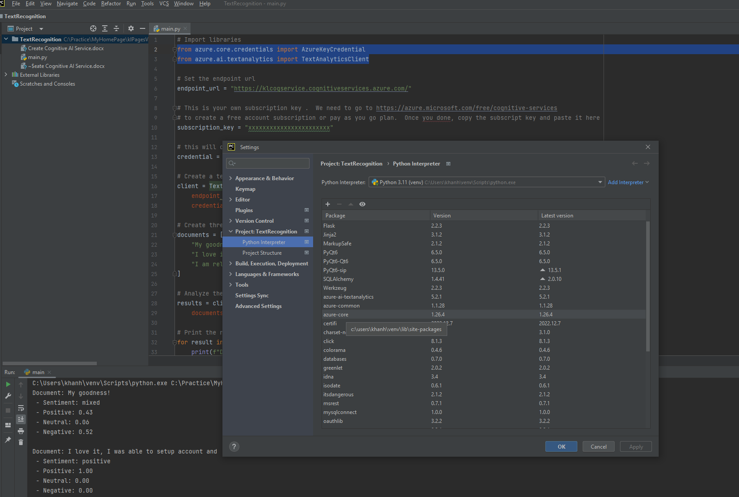

- Edit Endpoint url and subscription key so program can access your Azure account.
Go to the Cognitive Service just created, click on its name klCogService->click on Keys and EndPoint
- Click on ShowKeys and copy Endpoint ulr and Key1; then, paste in python program to run
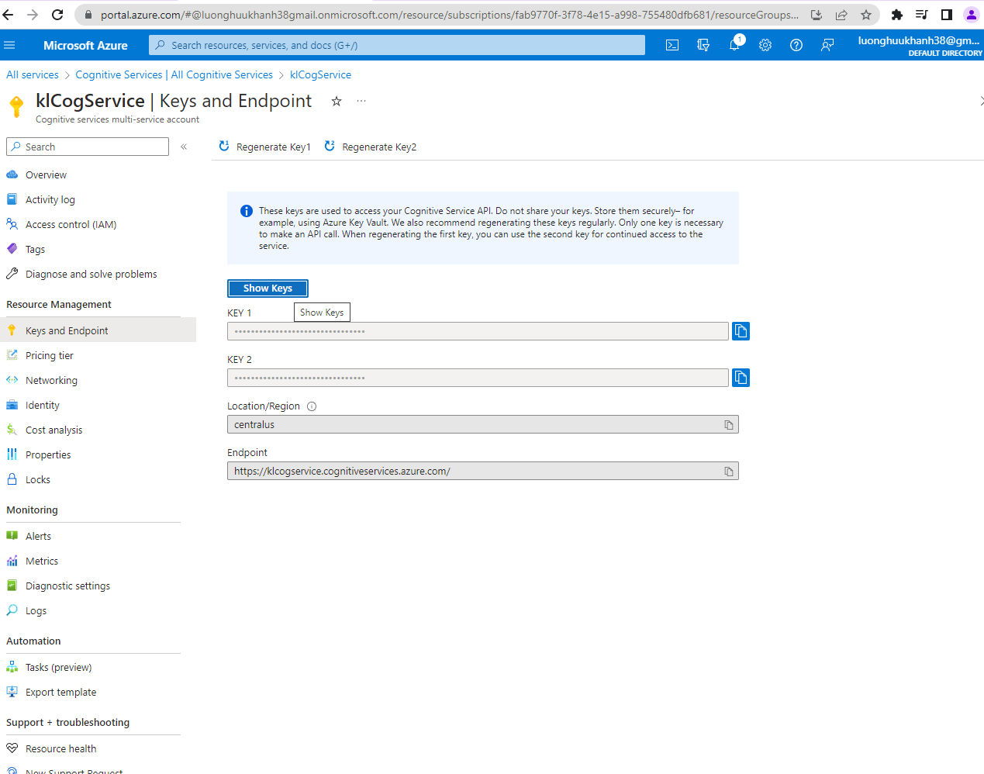

And paste it in the below section of the program
# Set the endpoint url
endpoint_url = "https://klcogservice.cognitiveservices.azure.com/"
# This is your own subscription key . We need to go to https://azure.microsoft.com/free/cognitive-services
# to create a free account subscription or pay as you go plan. Once you done, copy the subscript key and paste it here
subscription_key = "xxxxxxxxxxxxxxxxxxxxxxx"

3. Result of running this python program as the following
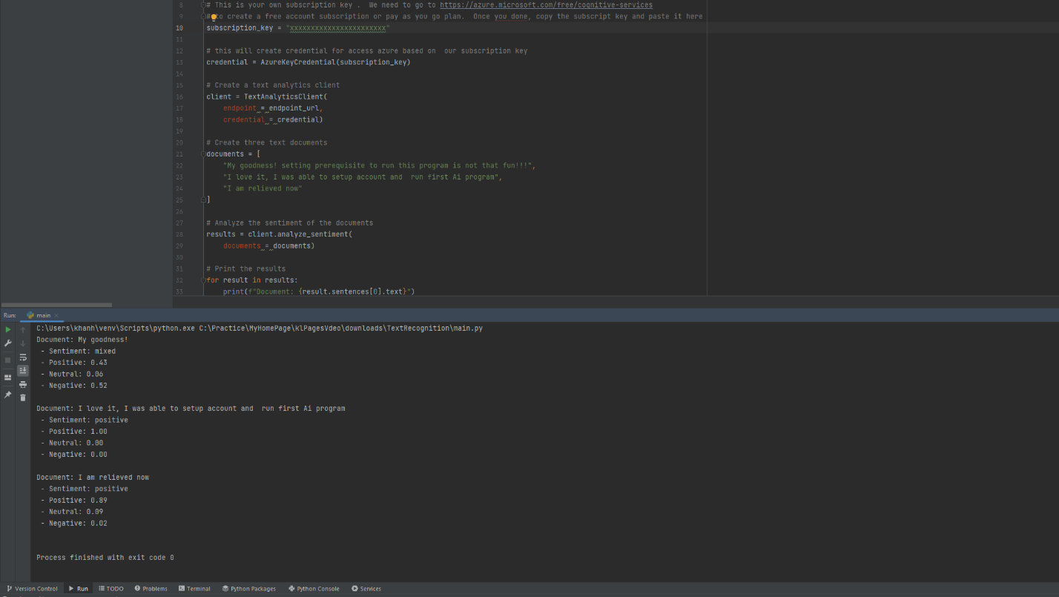

documents = [
"My goodness! setting prerequisite to run this program is not that fun!!!",
"I love it, I was able to setup account and run first Ai program",
"I am relieved now"
]

The program evaluate the text result as the following output:

